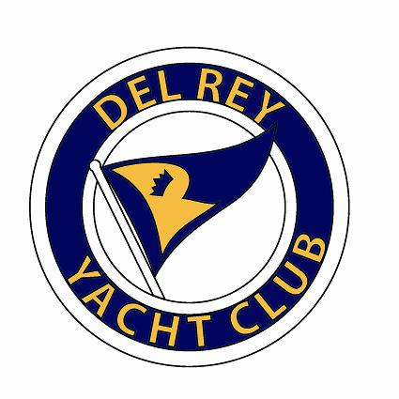
2016 SCYRA Optimist Midwinter Regatta
Steven M. Pitts Memorial Trophy
Carrie Series #4

Del Rey Yacht Club – February 6-7

Notice of Race

1. RULES

1.1 The regatta will be governed by the rules as defined in The Racing Rules of Sailing. (RRS).
1.2 The “class rules” for the purposes of the definition of “rules” are the International Optimist Assoc. Class Rules.
1.3 RRS 61.1 (a-2) will be deleted.
1.4 RRS Appendix P will apply.
1.5 Sailors do not need to be members of their respective national class association. This changes NOR 2.2.

2. NOTICE TO COMPETITORS

2.1 Notices to competitors will be posted on the official notice board that will be in the junior’s patio area.

3. FEES

3.1 The entry fee will be $50 per boat. The entry fee will include a T Shirt, lunch / snack bag, Saturday dinner.
3.2 There will be a $10 fee for registrants signing up after February 1st.

4. SCHEDULE OF RACES

4.1 Saturday
4.1.1 1000 Champ Fleet Skippers Meeting (inside in bar/lounge area), Green Fleet Skippers Meeting to immediately follow (inside in bar/lounge area)
4.1.2 1155 First warning (5 minute sequence) – Champ Fleet (off Venice Pier)
4.1.3 1157 First warning (3 minute whistle sequence) – Green Fleet (Channel Adjacent to DRYC)

4.2 Sunday
4.2.1 0900 Champ Fleet Skippers Meeting (inside in bar/lounge area), Green Fleet Skippers Meeting to immediately follow (inside in bar/lounge area)
4.2.2 1055 First warning (5 minute sequence) – Champ Fleet (off Venice Pier)
4.2.3 1057 First warning (3 minute whistle sequence) – Green Fleet (Channel Adjacent to DRYC)

4.3 4.3.1 A total of seven races are scheduled. Three races constitute a regatta.

5. SAILING INSTRUCTIONS

5.1 The sailing instructions will be available at registration.

6. PARKING / BOAT LAUNCH

6.1 Optis may launch at DRYC.
6.2 DRYC will provide overnight boat storage.

7. RACING AREA

7.1 The Champ Fleet will race outside (ocean) off the Venice Pier.
7.2 The Green Fleet will race in the Marina Del Rey Entrance Channel.
7.3 Racing area changes are up to the discretion of the race committee.

8. SCORING

8.1 The Low Point Scoring System of RRS Appendix A will apply, with the following modification: when
fewer than six (6) races have been sailed, a boat’s series score will be the total of all her race score when six (6) or more races have been sailed, a boat’s series score will be the total of her race scores excluding her worst score.
8.2 One (1) race must be completed to constitute a regatta.

9. PERSONAL BUOYANCY, WHISTLE, AND BOW LINE

9.1 Each competitor must wear a US Coast Guard approved personal flotation device (PFD), properly secured at all times while on the water except when temporarily adding or removing clothing. Wet suits, dry suits and inflatable PFD’s do not constitute adequate personal buoyancy. Failure to wear one will result in a penalty up to and including disqualification at the discretion of the protest committee.
9.2 Each competitor must have a whistle attached to their PFD at all times while on the water.
9.3 Each boat must have a secure loop in the end of its bow line.

10. SAFETY AND ADULT RESPONSIBILITY

10.1 An adult (parent, guardian or designated adult) is responsible for the safety of the each sailor. It is the responsibility solely of this adult to decide if the sailor should sail in the weather and sea conditions that might arise during the event. The adults supervising the competitors are ultimately responsible for the risks. The organizing authority will not accept any liability for material damage or personal injury or death sustained in conjunction with or prior to, during, or after the regatta.
10.2 Parents not personally attending any part of the event must ensure that another adult is authorized and designated to make these decisions for their sailor, and each competitor shall indicate in writing the parent or adult representative that shall be responsible for the competitor throughout the event.
10.3 The designated adult will accept full responsibility for all actions of the competitor during any activity related to the event. This includes on-shore activities before, during, and after the regatta.

11. SUPPORT/COACH BOATS

11.1 Support Boats may be launched at Del Rey Yacht Club. Trailer storage is also available.
11.2 Race Committee, Support, and Coach boat communications will be on Channel 72, unless modified by verbal instructions over that channel at the beginning of the race day.
11.2 Coach and support boats that do not follow the directions of the race committee or DRYC staff may be excluded from the venue, which can include the racing area, patio area, clubhouse, and/or club grounds.
1.3 Coach boats may be excluded from the race course by the RC for violation of the sailing instruction or behavior determined by the Race Committee to be inappropriate. Excluded boats that do not leave the race area may result in individual racers or the club teams being disqualified.

12. HOSPITALITY

12.1 Continental breakfast will be served on Saturday morning only.
12.2 Dinner will be served at DRYC on Saturday after racing. Dinner costs are included in the entry fee for
participants. Additional tickets for family and friends will be available for purchase at the door.

DRYC Website: http://www.dryc.org/
DRYC Main Office: (310) 823-4664
DRYC Junior Room: (310) 822-5182

